**Дата**: 17.12.2024

**Клас**: 9-АБ

**Предмет**: англійська мова

**Тема:** Контроль аудіювання.

**Мета:** : формувати навички вживання лексичних одиниць по темі; удосконалювати навички читання, аудіювання й усного монологічного мовлення; розвивати пізнавальні інтереси учнів; виховувати інтерес до самостійного пошуку потрібної інформації, а також загальну культуру учнів.

**Вчитель**: Руда Д.В.

Хід уроку

1.Greeting

Good afternoon, guys! I’m glad to see you. Are you ready to start our lesson? All set?

2. Wаrm up / Listening

Уважно слухати аудіо трек і дати відповідь на питання <https://www.youtube.com/watch?v=E9yr7wd-kd4> .

3. Speaking

Дати усно відповіді на питання :

What is your favorite karaoke song to sing?

What is your favorite kind of music?

What kind of music do you like?

What kind of music do you listen to to cheer you up?

What kind of music do you usually listen to?

What kind of music do your parents listen to?

What kind of music you like the most?

What kind of songs do you like to sing?

What kinds of music do people listen to in your country?

What kinds of music do you dislike?

What musicians did you like when you were in junior high school? How about high school?

What radio station do you usually listen to?

What was the last CD you bought?

What was the last concert you went to?

What was your favorite music five years ago? 10 years ago? How have your musical tastes changed?

When was the last time you went dancing?

When was the last time you went to a concert?

Where do you usually listen to music?

Which do you prefer, songs in English or songs in your own language?

Who is your favorite singer or group?

Who is your favorite singer?

Why do you think music is important and how does it affect different people?

Why is music so important to people and culture?

Is the image of the group or singer more important than the music?

Can you think of examples of music calming people or increasing their efficiency?

Do you mind singing to other people? (Another wording: ...singing in front of people?)

If you don't mind then how large an audience would be too many?

While listening to the radio, do you ever want to sing the song that is being played?

Why do you think some people believe opera singers should be fat?

Do you ever download MP3 files from the Internet?

Do you prefer rock music or romantic music?

Do you think music can heal sick people?

Do you think that animals can enjoy music? How do you know?

Do you think that music can help make world peace? How?

4. Повторення

Повторити фразу to be into something- захоплюватися чимось/to be good at smth- розбиратися в чомусь/to be interested in smth- цікавитися чимось.

Повторити Conditional sentences.(1/2/3 типи)

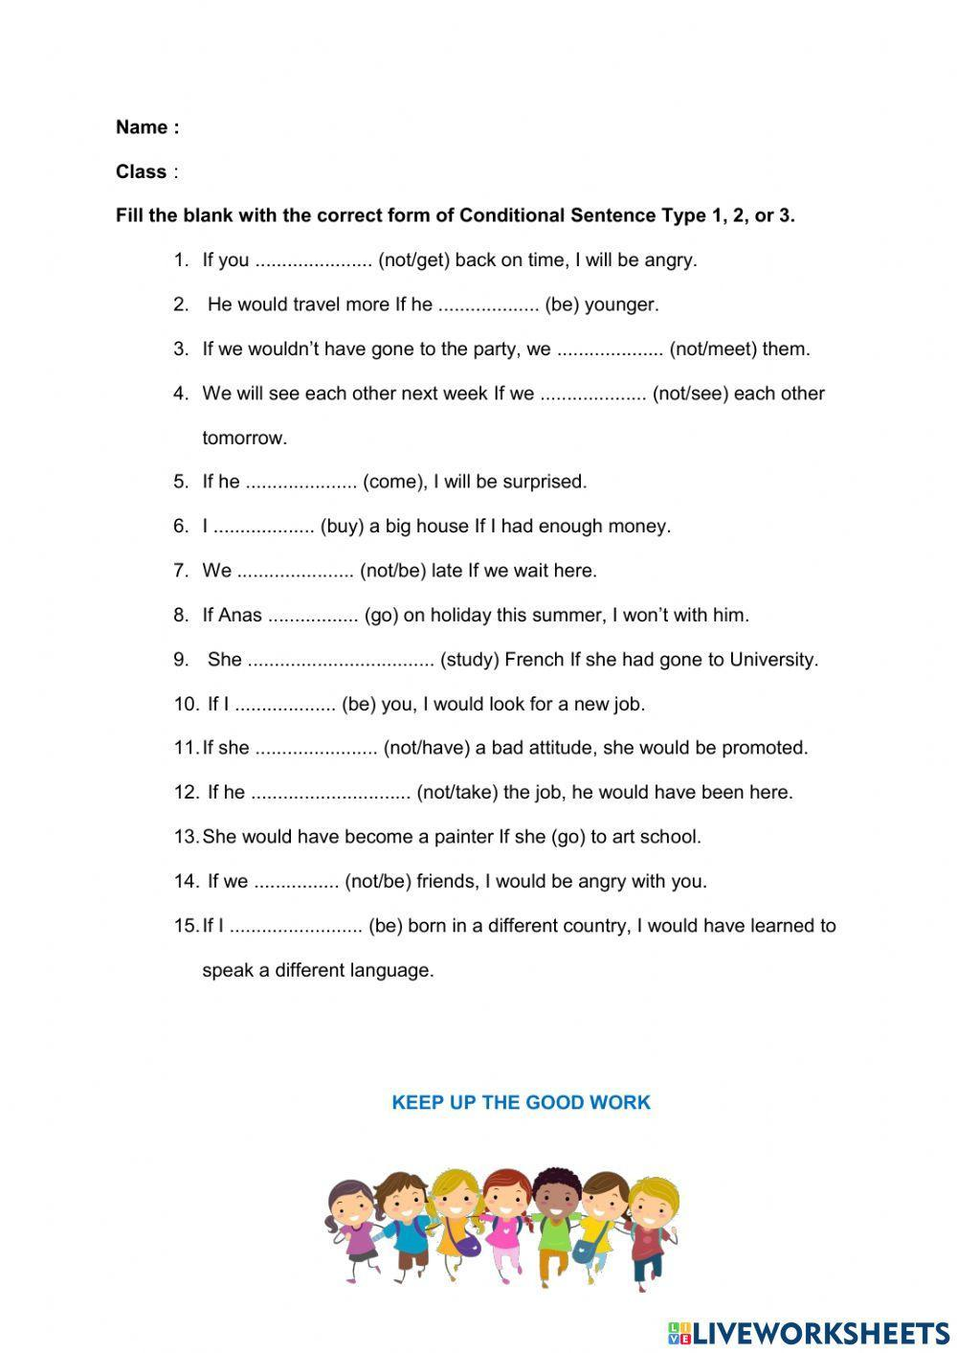

5. Writing

1. Написати міні-есе на тему «My plans for winter holiday».( обсяг 12 речень)

6. Homework

1. Виконати завдання на аркуші А4. (контроль аудіювання)

Аудіо <http://metodportal.com/node/83232>

Завдання

І семестр 9 клас

Контроль аудіювання.

Мета: перевірити рівень сформованості навичок аудіювання, розуміння загального

змісту текста , визначити рівень засвоєння лексичного матеріалу за темою.

1. Listen to the audio 1

2. 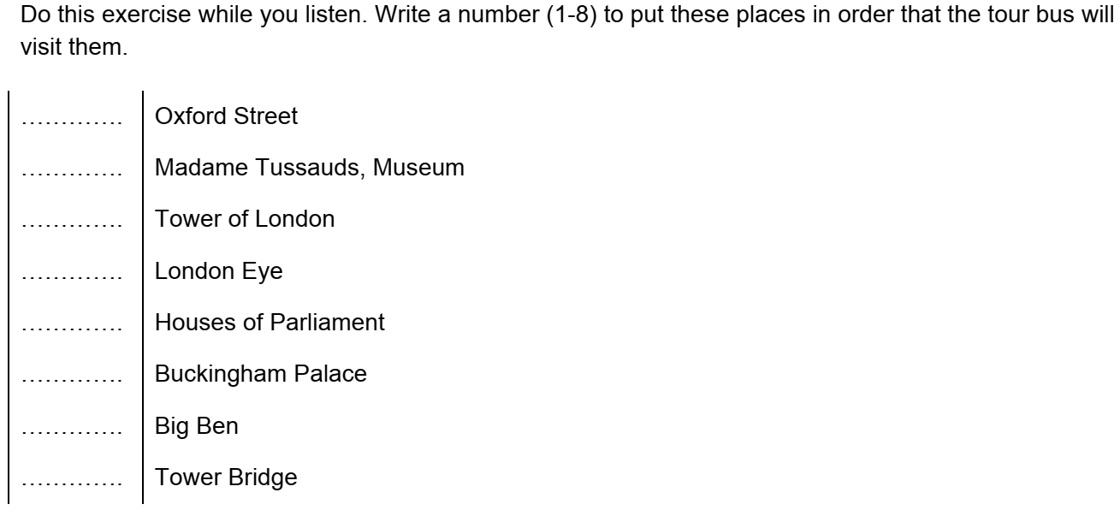

3. 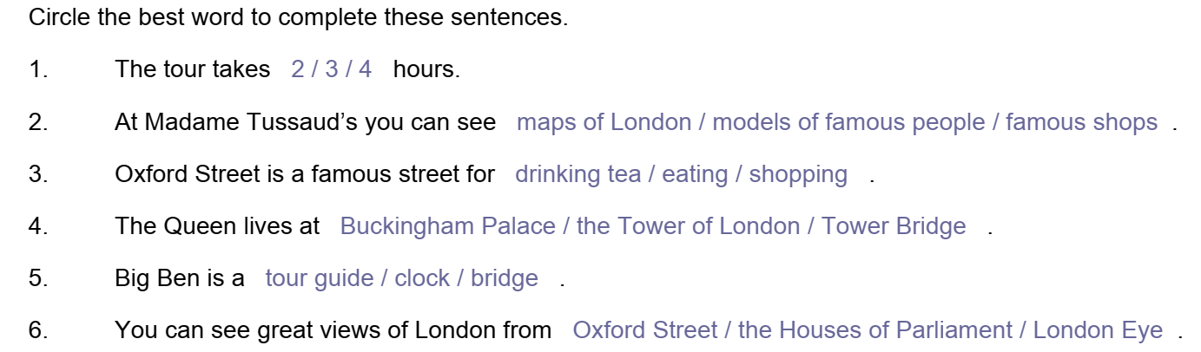

4. Listen to the audio2.